

INTI INTERNATIONAL COLLEGE SUBANG JAYA

CENTRE OF AMERICAN EDUCATION (CAE)

ASSIGNMENT 2 (15%)

Programme Name | AMERICAN UNIVERSITY PROGRAM (AUP)
Module Name | PROGRAMMING IN C++ |  | Module Code |  | CSC206
Module Name |  |  | Session/Semester |  | Jan 2021
Module Leader Name | Mr K SHIVA |  | Assessment Type / Reference No. |  | ASSIGNMENT 2 / Jan 2021
Student Name |  |  | Student Identification IC/Passport No.
Student’s declaration | I hereby certify that this assignment is my own work and where materials have been used from other resources, they have been properly acknowledged. I also understand I will face the possibility of failing the module if the content of this assignment is plagiarized.  Signed: ________________________ Date: _________________
 | - CLO1: Evaluate programs using object-oriented approach. (C5, PLO2).
Learning Outcomes (s) / | - CLO2: Solve a suitable solution for any given problem using C++ programming language (C3, PLO1)
 | - CLO3: Apply file processing, bitwise manipulation and data structures in C++ programs (C3, PLO1).
Release Date | 04.03.2021 | Submission Due Date |  | 29.03.2021, at 9AM | Marks obtained
  CLO3: Apply file processing, bitwise manipulation and data structures in C++ programs (C3, PLO1).
Date Received |  | Student’s work assessed by / date |  |  | Marks obtained

TASKS

TASK 1 (30%):

Define a class called Time. This class should have four (4) data members:
- hour
- minute
- second
- an AM/PM tag
The class should have the following properties:
- It should have a constructor to initialize these data members. Remember, midnight is 12:00:00 AM.
- It should have a member function to increment the second. However, remember that when the number of seconds passes 60, second must be reset to 0 and the minute must be incremented. You will need similar logic for hour and for the AM/PM flag.
It should have a member function to print the time, test your Time class, which should produce the output as follows.
The Time is 11:34:56 PM
Enter time increment in seconds: <5>
The time is now: The Time is 11:35:01 PM
Sample Output (Basic requirements):
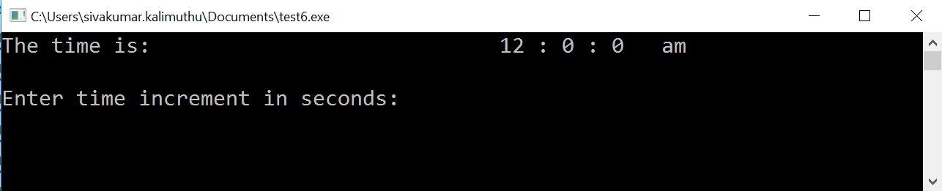
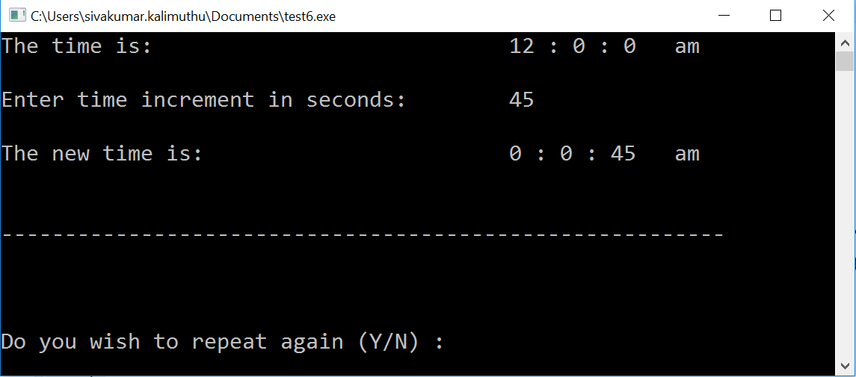
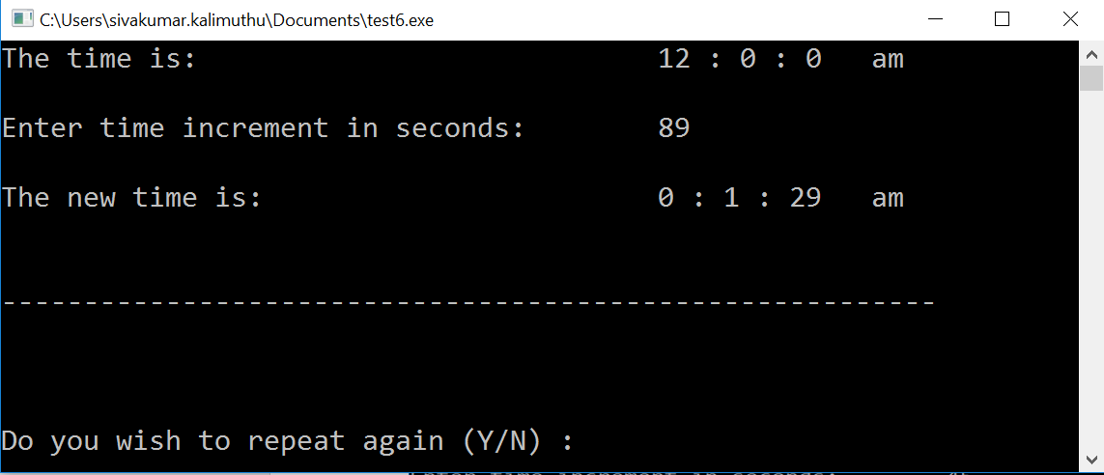
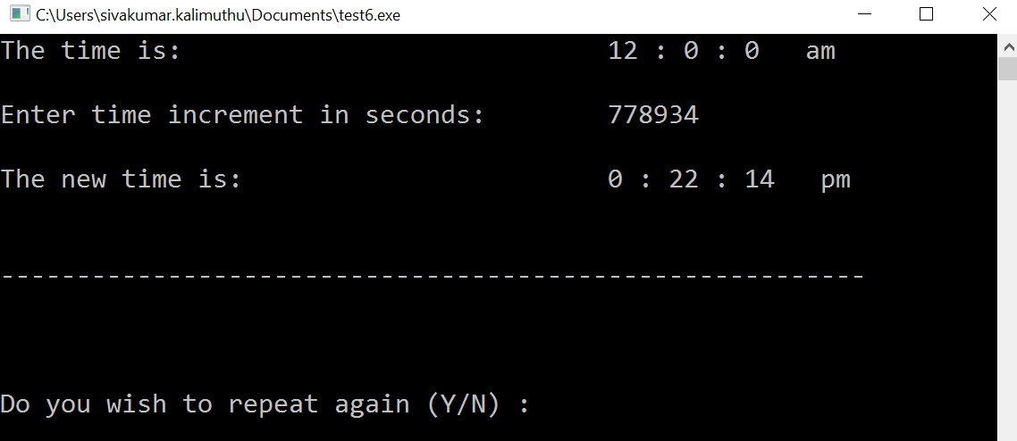

Grading Rubrics

(Outstanding) | (Excellent) | (Good) | (Fair) | (Poor)
Basic requirements, execution, logic, validation, runtime, critical thinking, any other additional functions (23-30). | Program executes correctly with no syntax or runtime errors, validation, creativity of application (17-22) | Meet the basic requirements but acceptable. No syntax, runtime, logic error (13-16) | Program executes with a minor (easily fixed error) (6-12) | Program does not execute (0-5)
TOTAL

Task 2 (60%):
Consider that, a video store would like to manage its collections of videos electronically. You are to write a C++ program for keeping track of video records. For each video in the store the system is to keep the following information are minimum requirement.
- Admin account (he/she needs to login)
- category (comedy, adventure, action)
- Title of the video, run time in hours or minutes, stars, director, etc.,
- The number of available copies of video in each category.
The video store only has a maximum of 9 different videos in its collection. Each category can store only maximum of 3. In ADMINISTRATOR can include new video (if there are possibilities, but maximum are 3 video records on each category) or modify the video records details. While creating video records admin has to enter all information (user id, password) manually to proceed to add/modify the video records. Therefore, admin has to provide a valid user id & password to check whether the admin account is existing or not. If it exists, then it displays Video record shop details (you could provide any details on your own). If it matches, then a menu driven screen is displayed to enable to add or modify the existing video records operations.
Example:
Possible case 1:
User ID: admin
Password: wrong password
Please enter correct ID/Password to proceed.
Possible case 2:
User ID: admin
Password: 12345
Hello, Welcome to Admin Page

******************************************************************************
* KENZ Videos & Records Sdn Bhd *
* 21 & 21M, Jalan 6/11, Taman Kommersial Pandan Indah, *
* Pandan Indah,55100 Kuala Lumpur, Malaysia. *
* Contact: +603-4296 0377 *
* Website: http://www.kenz.com.my/ * ******************************************************************************
Available Categories
- Action
- Adventure
- Comedy
- Exit
(Admin required to select from 1-4, if not match then the error message will be displayed to re-enter correct option).
If user/admin selects the number 1, then it will display the available videos, add new or modify the existing details if any. When admin who is tries to add new one (if there are 3 videos already stored) then error message will be shown and saying that which is exceeds the limit. Which is applicable to Adventure, comedy category as well. Upon successful entry to option 1 (Action), the system needs to display as follows (sample)

Category type: Action
List of available videos: 2
Maximum Limit: 3
List of available videos & records as follows:

Name of the movie: Venom
Star cast: Tom Hardy, Michelle Williams, Riz Ahmed
Director: Ruben Fleischer
Duration: 140 minutes

Name of the movie: Black Panther
Star cast: Chadwick Boseman, Michael B. Jordan, Lupita Nyong'o
Director: Ryan Coogler
Duration: 134 minutes
etc.,
Now, admin can able to include maximum of another two video records. When the admin (assume that, there is a request from the customer) takes out the requested movie/video, it will no longer exist in the category even if search operation applies. Just keep in mind this scenario and apply to all other category.
Sample Output (Basic requirements):
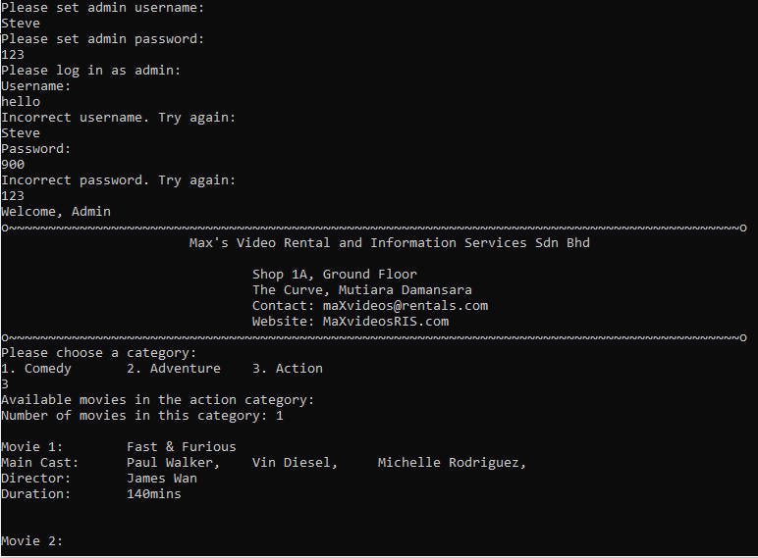
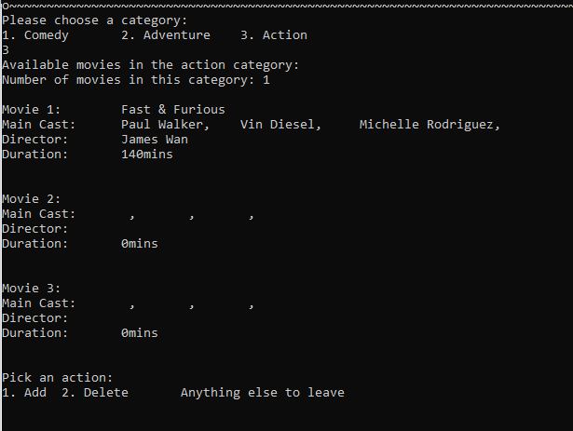

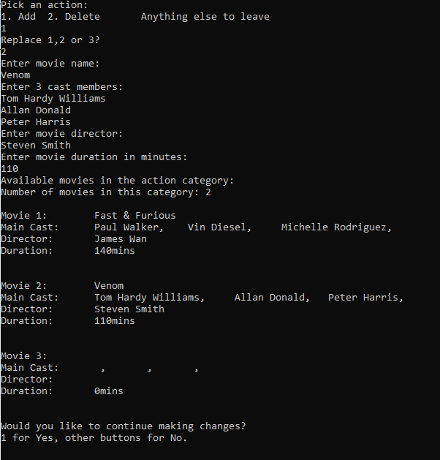
Grading Rubrics

(Outstanding) | (Excellent) | (Good) | (Fair) | (Poor)
Basic requirements, execution, logic, validation, runtime, critical thinking, any other additional functions (50-60). | Program executes correctly with no syntax or runtime errors, validation, creativity of application (40-49) | Meet the basic requirements but acceptable. No syntax, runtime, logic error (30-39) | Program executes with a minor (easily fixed error) (20-29) | Program does not execute (0-19)
TOTAL

Task 3 (10%):
Write a function template named maximum. The function takes two values of the same type as its arguments and returns the larger of the two arguments (or either value if they are equal). Give both the function declaration and the function definition for the template. You will use the operator < in your definition. Therefore, this function template will apply only to types for which < is defined. Write a comment for the function declaration that explains this restriction.
Sample Output (Basic requirements):
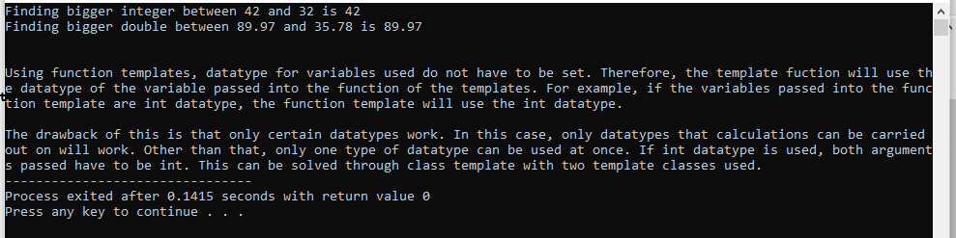
Grading Rubrics

(Outstanding) | (Excellent) | (Good) | (Fair) | (Poor)
Basic requirements, execution, logic, validation, runtime, critical thinking, any other additional functions (9-10). | Program executes correctly with no syntax or runtime errors, validation, creativity of application (7-8) | Meet the basic requirements but acceptable. No syntax, runtime, logic error (5-6) | Program executes with a minor (easily fixed error) (2-4) | Program does not execute (0-1)
TOTAL

Instructions to Students:
- Submit soft copy to sivakumar.kalimuthu@s.newinti.edu.my.
- No late submission will be accepted.
- Plagiarism is an academic dishonesty. Submit your work in original. F grade will be awarded for a plagiarized/copied work.
- Submission on before 29.03.2021, 9AM

